Program Cover Sheet

|  |
| --- |
| Name: Alex Coldwell |
| Assignment: Assignment 5 |
| List any parts of the assignment that do not work/were not completed:  (None) |

|  |
| --- |
| Instructor’s Comments: |
| Grade: |

Program Submission Requirements: (1) all files, zipped and uploaded to Canvas and (2) a completed cover sheet, program execution screenshots and source code printed, **stapled** and turned in during class. Failure to follow the submission requirements will result in points lost on that particular assignment.

**Wrong Path:**

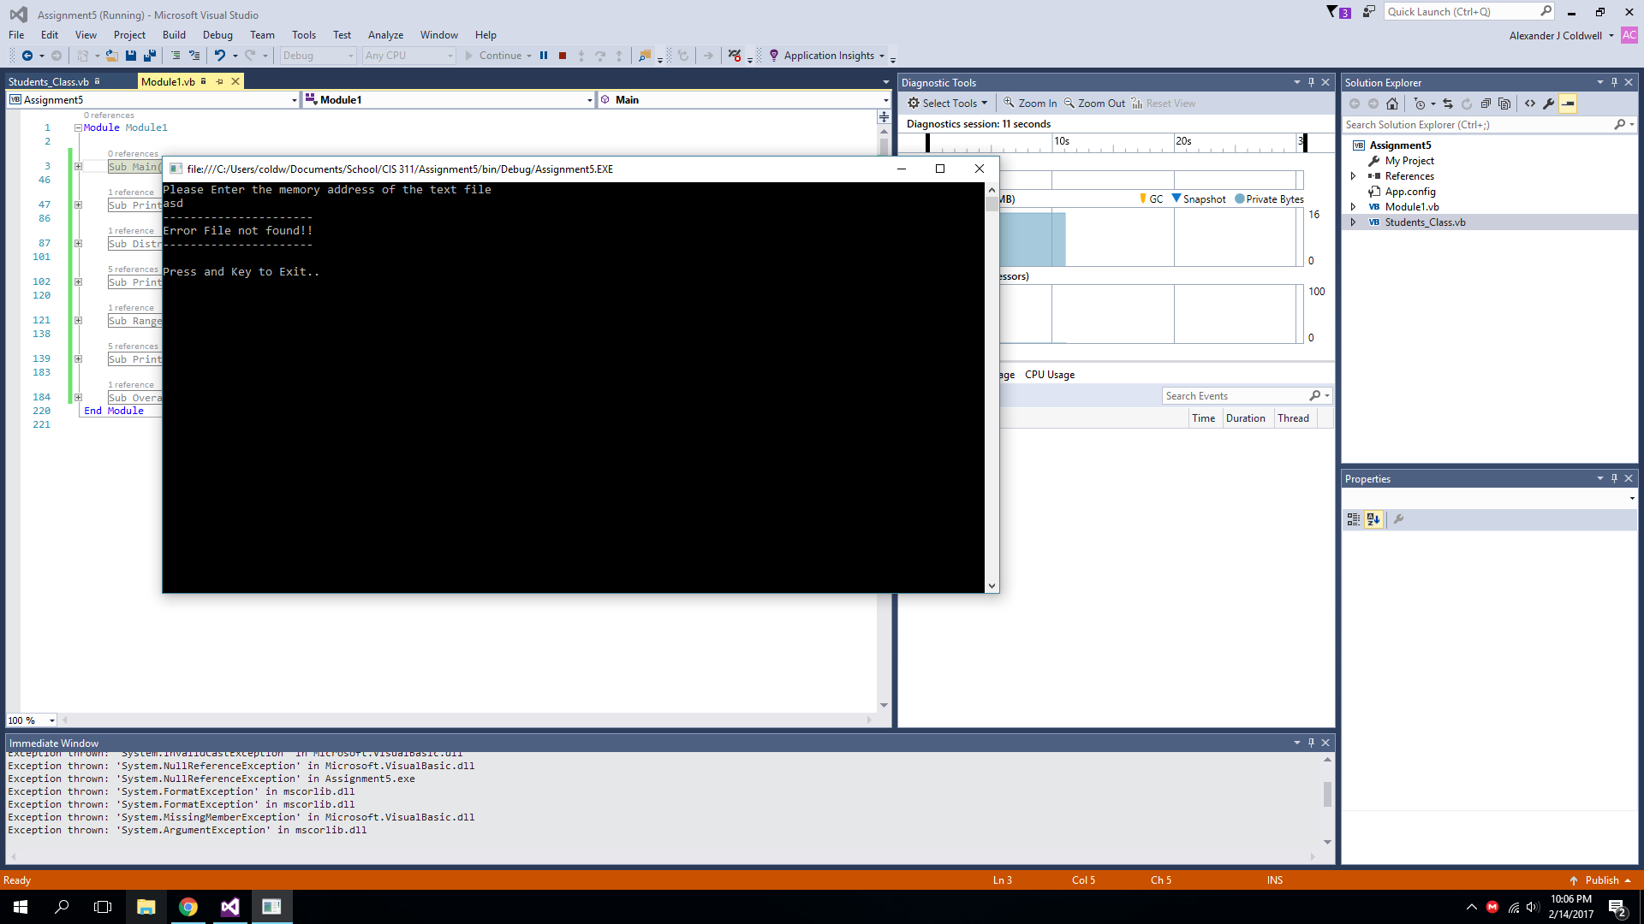

**Grade Report**

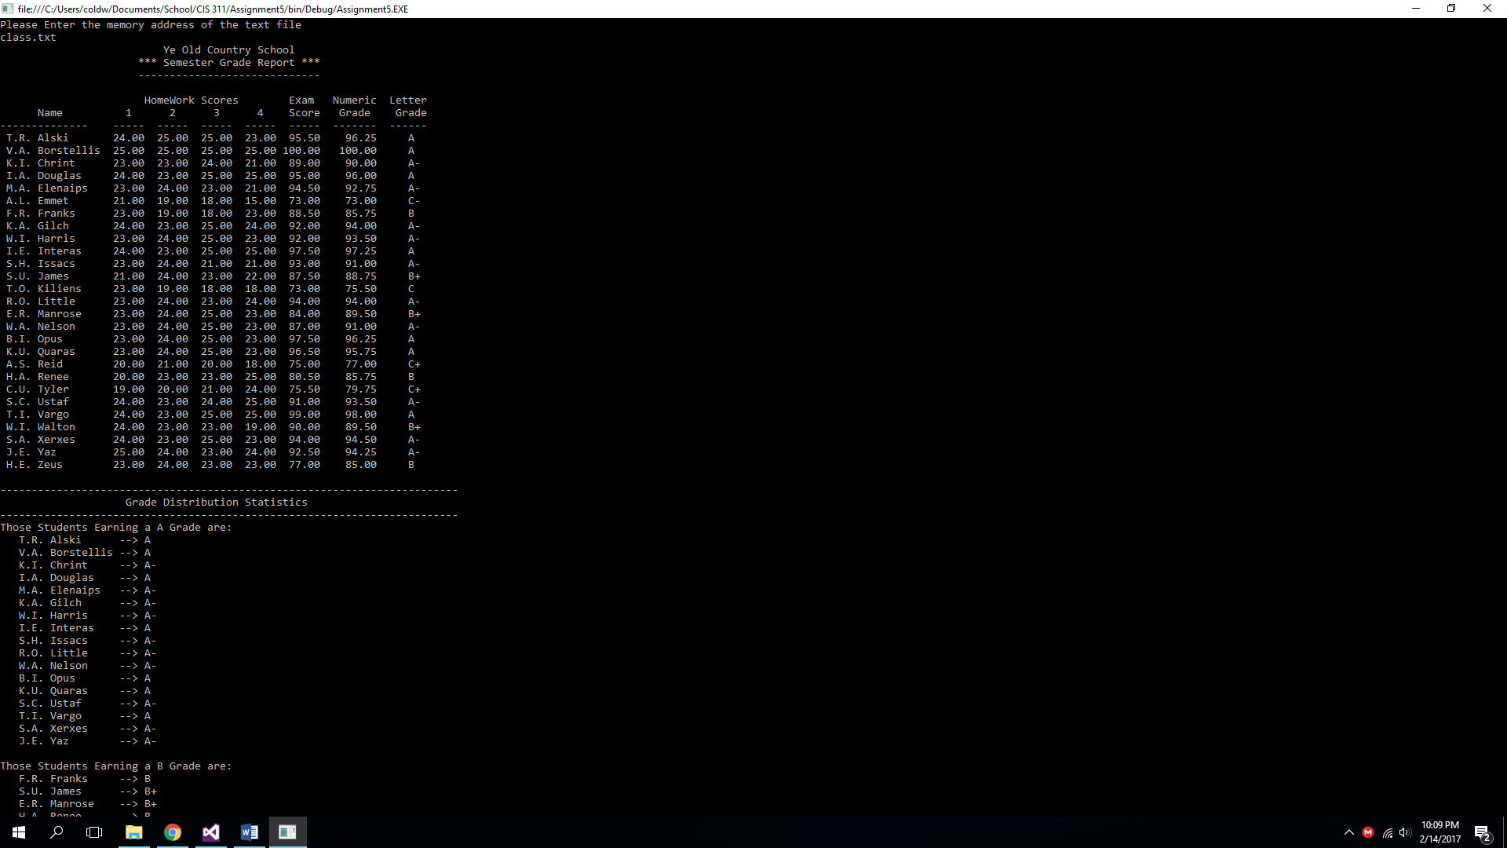

**Grade Distribution Statistics/HomeWork/Exam Grade Range Statistics**

